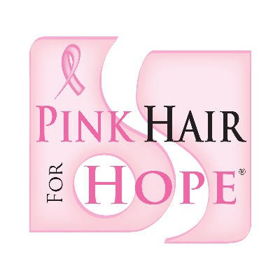
NEWS RELEASE

FOR IMMEDIATE RELEASE Contact: Alexa Hillery
9/24/2012 618-520-9901
ahiller@siue.edu

Alpha Sigma Tau Spreads Cancer Awareness
Pink Hair for Hope Fundraiser Turns Heads to Pink

EDWARDSVILLE, Ill. – The Beta Eta chapter of Alpha Sigma Tau is holding their 4th annual Pink Hair for Hope event at Southern Illinois University Edwardsville. Pink Hair for Hope raises funds and awareness toward breast cancer by gluing pink strands into people’s hair.
This event grows every year, with the sorority offering strands not only to students this year, but also to members of the community. Kayla Bartz, a junior at SIUE, has noticed each year more people having pink in their hair. “My freshman year, it was just the sorority girls, but last year everyone had them.”
Pink Hair for Hope rose over $4000 last year and Kara Combs, Alpha Sigma Tau’s philanthropy chair, says the goal this year is to raise $5000. Funds will be raised by selling strands at $10 apiece, hosting vendors that will donate 10% of their proceeds back to Pink Hair for Hope, and a volleyball tournament held in congruence with the event.
Pink Hair for Hope will be held October 23 and 24 in the evening from 4 until 9. Express passes may be purchased before the event in the Morris University Center on October 18, 19, and 22 between 11 and 2. For more information, visit Alpha Sigma Tau’s website or find their event on Facebook.

